Moral Judgments Impact Perceived Risks from COVID-19 Exposure
Cailin O’Connor, Daniel P. Relihan, Ashley Thomas, Peter H. Ditto, P. Kyle Stanford, James Owen Weatherall
May 5, 2021
Abstract:
The COVID-19 pandemic has created enormously difficult decisions for individuals trying to navigate both the risks of the pandemic and the demands of everyday life. Good decision making in such scenarios can have life and death consequences. For this reason, it is important to understand what drives risk assessments during a pandemic, and, in particular, to investigate the ways that these assessments might deviate from ideal risk assessments. Two studies (N = 841) investigate risk judgments related to COVID-19. The results indicate that risk judgments are sensitive to factors unrelated to the objective risks of infection. In particular, activities that are morally justified are perceived as safer while those that might subject people to blame, or culpability, are seen as riskier.

1. Introduction
In July of 2020 the Texas Medical Association released an infographic communicating COVID-19 risks for various activities. The infographic categorizes activities into risk levels in order to help readers make informed decisions about their own behaviors. But some of the rankings seem to be at odds with our best medical and scientific knowledge about COVID-19 transmission. In the infographic, going to the beach is ranked as riskier than going to the library, museum, or a doctor’s waiting room, despite the fact that outdoor spaces have been widely found to be safer than indoor ones. Playing basketball is ranked as riskier than spending a week working in an office building, again despite the fact that basketball is often an outdoor activity, and one that is relatively short-lived. Other such infographics display similar trends: outdoor recreational activities such as going to the pool or playground are often ranked as riskier than indoor activities like grocery shopping. Seeing a doctor is routinely ranked as a low risk activity, despite the fact that it occurs indoors and involves exposure to individuals who see many (possibly sick) patients on a daily basis. One such infographic from Nebraska Medicine rates a doctor’s visit as less risky than getting gas.
Accurately assessing COVID-19 risks across activities is difficult. Therefore, it is unsurprising that there is conflicting information on this topic. But it may be that something more systematic is at work here. It seems that rather than reflecting a purely actuarial assessment of the likelihood of contracting COVID-19 from various types of activities, these risk judgments may actually reflect wider judgments about whether or not an individual ought to engage in a behavior. For example, going to the doctor’s office is important, and failing to see a doctor might lead to serious problems down the line. All things considered, a decision to see a doctor is a justifiable one, and thus one that experts might recommend. In labelling a doctor’s visit as low risk, it seems that public health experts may be making a judgment about whether the behavior is laudable, ought to be engaged in, or advisable all things considered. Behaviors that are not justified are labelled as riskier.
Moral judgments play a role in this process. Previous work has found that moral judgments can impact factual beliefs, perhaps as a result of motivations for explanatory coherence (Clark et al. 2015; see also Read et al., 1997; Thagard, 2000). Humans seek to create coherent narratives about the world, and in doing so, their moral beliefs shape their factual ones. Work on the culpable control model shows that in cases where people are perceived as blameworthy, their actions are also perceived as more intentional (Knobe, 2003; Burra & Knobe, 2006). In addition, they are seen as more causally responsible for outcomes of their actions (Alicke, 2000; Hitchcock & Knobe, 2009; Kominsky et al., 2015), and more in control of outcomes (Cushman et al., 2008). (For an overview, see Knobe, 2014). In other words, people reverse engineer good factual reasons to support their judgments of blameworthiness and moral culpability. Likewise, and especially relevant here, moral judgments shape judgments about the likely consequences – harms and benefits – of certain behaviors. Liu and Ditto (2013) find that manipulating beliefs about the wrongness of the death penalty changes people’s factual beliefs about whether it can deter crime, and about the likelihood of executing innocent people. This influence of moral judgments on factual beliefs extends to beliefs about risk. Thomas et al. (2016) find that subjects judge unattended children to be in riskier situations when their parents leave them alone for morally suspect reasons, even when real risk is controlled. Relihan et al. (in prep) likewise find that moral beliefs shape risk perception across a number of situations. For example, subjects in their studies thought that questionable actions carried more risk of harm to others when performed intentionally than unintentionally.
In the current studies, we investigate the possibility that a similar phenomenon could bear on judgments about the risks of COVID-19. In judging COVID risks, perhaps people respond to whether or not an individual is culpable for engaging in the activity that potentially exposes them or others. We consider several factors that might influence such a judgment: the moral valence of an activity, its importance, and whether or not an individual intended to engage in it. All three factors can provide good reasons for an individual to have engaged in a potential exposure activity: an individual may have a moral responsibility to perform an action; it may be important for them to do so; or they may have no choice in the matter. In each case, the presence of one of these factors might alleviate judged culpability for engaging in a risky behavior. We hypothesize that a desire for coherence might then drive people to judge these well-motivated behaviors as less likely to produce infections.
To test our hypothesis, we presented vignettes where risk factors remained stable, but where the intentions and context for exposure varied. We expected subjects to judge actions as less risky when individuals exposed themselves for morally positive reasons, while engaged in important actions, or unintentionally. We found that two of these predictions held. Behaviors judged as morally good or as unintentional were judged as less risky. As noted, intentionality is tied to moral judgment. For example, unintentional actions are typically judged as less morally culpable (Shaver, 1985; Nichols & Knobe, 2007; Clark et al., 2015). And previous work considering the impacts of moral judgment on risk has used intentionality as a stand-in for the morality of an action (Thomas et al., 2016; Relihan et al., in prep). Altogether, we take our findings to show an impact of moral judgment on risk judgment related to the COVID-19 pandemic.
Our study design was sensitive to the fact that there is a tight connection between judgments about morality and about importance. Highly moral actions are often judged as highly important, and vice versa. This relationship is likely to be exacerbated during a global pandemic where exposure can create negative outcomes for oneself and others. In such a context, going to the doctor, getting gas, and playing basketball may all be subject to moral judgments. We varied these two factors systematically within one set of vignettes in order to test whether both factors influenced risk judgments independently. We found that judgments about whether a behavior was important were correlated with judgments about how risky it was. Upon controlling for judgments about the morality of the behavior, however, we found only minimal evidence that perceived importance independently influences risk judgments. Conversely, risk judgments were affected by moral judgments even after controlling for the importance of the activity. Note that the observed connection between morality and importance judgments may help shed light on risk judgments, like those seen in various infographics, that seem to track broadly whether or not an individual should engage in some behavior, rather than COVID risk alone.
In section 2 we discuss our general methods. In sections 3, 4, and 5 we present further details of the design and results from a pretest, and two experiments. The first experiment considers the impacts of morality and importance on COVID-19 risk judgments, and the second considers the impacts of intentionality on these judgments. In section 6 we conclude with a general discussion of our results.
2. General Method
We administered both a pretest (N = 446) and two studies (N = 839). We give an overview of the general method before describing these components in detail. This study was preregistered under the Open Science Foundation (OSF). We adhered to the methods described in our preregistration except where otherwise noted.
2.1. Overview. We invited participants on the Prolific online platform to read vignettes where an individual is potentially exposed to COVID-19. These vignettes were organized under vignette types. In each vignette-type the name, age, and location of the individual in question remained the same. In addition, the exposure event remained identical. The vignettes within a vignette-type varied only with respect to the reasons for the individual’s exposure. In study 1 we varied motivations for exposure with respect to moral valence and importance. We varied both of these two motivations independently in study 1 because moral valence and importance judgments coincide. That is, subjects generally judge highly moral actions as of high importance as well. Part of our goal was to establish whether both factors influenced risk judgments independently, or whether they interact. In study 2 we varied whether or not the exposure was intentional, with just two conditions—intentional and unintentional. After reading each vignette participants were asked to estimate how risky the behaviors of the participants were with respect to COVID-19. In addition, we asked questions tracking participants’ judgments about the morality and importance of the behavior portrayed in the vignettes (study 1) and the intentionality of that behavior (study 2). In our pretest we additionally asked participants to make judgments about the necessity of the portrayed behaviors as a robustness check.
2.2. Participants. Participants were recruited online through Prolific, and were each paid $1.90 for completing the survey, which took about 12 minutes. All participants were U.S. citizens currently living in the United States. Participant data was excluded if participants failed an attention check. This involved an extra vignette with instructions to choose a particular answer. Participant data was also excluded if participants finished the survey too quickly. After reviewing data and survey times from our pretest, we set this cut-off at five minutes.
2.3. Procedure. Participants were given a set of instructions informing them that they would read eleven vignettes (or “scenarios”) and be asked to make judgments about the individuals involved. They were instructed to take their time, and watch for attention checks. Participants then read six vignettes as part of study 1. These were drawn from each of six vignette-types (see table 1). For each vignette-type we generated six conditions, corresponding to combinations of morally good, morally neutral, and morally bad, as well as high and low importance, reasons for the individual’s actions. (For a full list of all vignettes used, see Appendix A.) This yielded vignette-types, for instance, that were morally good-low importance, morally neutral-high importance, etc. Each participant was randomly assigned a block of questions which included one from each vignette-type and one from each condition. This ensured that all participants saw each condition and each vignette-type. Within each block, vignettes were ordered pseudo-randomly to avoid ordering effects. This pseudo-random ordering was established ahead of time using a randomization device, and remained the same across all tests.
Table 1. Vignette Types for Study 1
Individual | Exposure
Alex (21) | Went to a crowded bar for an hour
Barbara (60) | Spent one hour in the public library
George (35) | Went to a busy grocery store for 45 minutes
Joe (52) | Stuck in an elevator for 25 minutes with 5 strangers
Justine (26) | Danced for 4 hours at a club
Mina (41) | Worked in her restaurant 12 hours a day for two weeks
Note: parentheses = age.
Following study 1, participants were presented with an attention check in the form of an extra vignette with instructions to select particular answers. All participants were then presented with four vignettes as part of study 2. These were drawn from four vignette-types (see table 2). There were two conditions for each vignette type, where individuals either intended or did not intend to engage in the behavior that potentially exposed them to COVID-19. Each subject was randomly assigned to a block of four questions, two from each condition. Again, these were ordered pseudo-randomly to avoid ordering effects while ensuring that each participant was exposed to each vignette-type and to each condition twice.
Table 2. Vignette Types for Study 2
Individual | Exposure
Andy (33) | Spent 5 minutes in the middle of a group of protesters
Kristi (45) | Walked briefly through a large, crowded bar
Olivia (24) | Spent two minutes in a small room with twelve friends
Peter (43) | Stayed in his apartment for one hour while a plumber worked on the bathroom
Note: parentheses = age.
Following both studies, every participant was asked to answer a series of demographic questions about their gender, age, racial/ethnic identity, and political orientation.
2.4. Data Analysis. Between-subjects analyses were conducted to pretest the effectiveness of the moral and importance condition manipulations. Analysis of variance (ANOVA) with Tukey HSD post hoc comparisons was conducted for each vignette in the study 1 pretest, and paired samples t-tests with Bonferroni corrections were used for each vignette in the study 2 pretest. To test the main hypotheses for studies 1 and 2, mixed effects models were constructed with random intercepts and slopes.
3. Pretest
Before completing studies 1 and 2, we administered a pretest to participants. The goal of the pretest was to ensure that the conditions in our vignettes indeed elicited the judgments about morality, importance, and intentionality that we expected.
3.1. Design. For each vignette in the study 1 pretest, participants were randomly assigned to a moral (morally good, morally neutral, morally bad) and an importance (low, high) condition (Table S1 in Supplemental Material). For each vignette participants responded to three items. The first item asked a morality question, “How moral/immoral was it for X to engage in the activity that potentially exposed him/her to COVID-19?” with responses “very moral (1), moderately moral (2), slightly moral (3), neither moral nor immoral (4), slightly immoral (5), moderately immoral (6), or very immoral (7)”. Participants were then asked an importance question, “To what degree was it important for X to engage in the activity that potentially exposed him/her to COVID-19?” with responses “very unimportant (1), moderately unimportant (2), slightly unimportant (3), neither important nor unimportant (4), slightly important (5), moderately important (6), or very important (7)”. For the pretest we also asked a necessity question with the intention of checking whether responses were similar to the importance question. Subjects were asked, “To what degree was it necessary that X engage in the activity that potentially exposed him/her to COVID-19?” with responses “very unnecessary (1), moderately unnecessary (2), slightly unnecessary (3), neither necessary nor unnecessary (4), slightly necessary (5), moderately necessary (6), or very necessary (7)”.
For each vignette in the study 2 pretest, participants were randomly assigned to an intention condition (unintentional, intentional) and first asked to answer an intentionality question, “To what degree did X intend to engage in the activity that potentially exposed him/her to COVID-19?” with responses “very unintentional (1), moderately unintentional (2), slightly unintentional (3), neither intentional nor unintentional (4), slightly intentional (5), moderately intentional (6), or very intentional (7)”. They were also asked to answer the necessity question described above to check robustness of answers.
3.2. Participants. Participants (N = 503) were recruited from Prolific on December 7th, 2020. One participant declined consent, one only provided demographic information, and 55 failed the attention check. Excluding these participants yielded a final sample of N = 446 (mean survey duration = 682 seconds, SD [standard deviation] = 422 seconds). No subjects were excluded for spending too little time on the survey, as part of the goal of the pretest was to establish a reasonable time cut-off for the final experiments. Participants ranged in age from 18 to 79 (mean age = 32.40, SD = 12.20; Table S2), 38.57% reported their gender as Man, 58.30% as Woman, 2.91% as Non-Binary, and .22% as Other/Prefer not to say. In response to the question “What is your race/ethnicity? Check all that apply” 64.57% reported that they were only Caucasian, 8.30% African-American/Black, 6.05% Latino or Hispanic, 10.31% Asian, .45% Native American, 0% Native Hawaiian or Pacific Islander, .22% Other/Unknown, and .22% Prefer not to say. Another 9.87% checked multiple racial categories. In response to the question “How would you describe your political views?” 21.80% of participants reported that they were Very Liberal, 28.76% Liberal, 13.48% Slightly Liberal, 18.65% Moderate/unsure, 7.19% Slightly Conservative, 7.87% Conservative, and 2.25% Very Conservative (mean political orientation = 2.93, SD = 1.64, range 1 to 7 where higher = more conservative).
3.3. Data Analysis. For the study 1 pretest, a 2 (importance condition: low vs. high) x 3 (moral condition: morally good vs. morally neutral. vs. morally bad) ANOVA was conducted with Tukey HSD post hoc comparisons for each vignette on moral, importance, and necessity judgments. For the study 2 pretest, independent samples t-tests were conducted with Bonferroni-adjusted alpha levels (α = .05 / 8 = .006) for each vignette comparing intention and necessity judgments between intentional and unintentional conditions.

3.4. Results and Discussion.
Full pretest results are presented in Supplemental Tables S1-S42. As expected for each vignette in the study 1 pretest, there was a significant effect of moral condition on moral judgments, F-values ranged from 17.86 to 167.04, all p-values < .001 (see Tables S39 and S40 for summaries). For all six vignettes, participants made significantly harsher moral judgments in the morally bad than the morally good conditions (differences between conditions ranged from 1.17 to 3.03, all p-values < .001) and significantly harsher moral judgments in the morally bad conditions compared to the morally neutral conditions (differences between conditions ranged from .79 to 2.39, all p-values < .001), suggesting that the morality manipulation worked. There were significant differences in moral judgments between morally good and morally neutral conditions for two of the six vignettes.
Also as expected, there was a significant effect of importance condition on importance judgments for each vignette, F-values ranged from 70.40 to 275.60, all p-values < .001. For all six vignettes, participants rated the action as significantly more important in the high importance conditions compared to the low importance conditions, differences between conditions ranged from 1.43 to 2.74, all p-values < .001. There was also a significant effect of importance condition on necessity judgment for each vignette, F-values ranged from 40.30 to 263.70, all p-values < .001. For all six vignettes, participants rated the action as significantly more necessary in the high importance conditions compared to the low importance conditions, differences between conditions ranged from 1.08 to 2.49, all p-values < .001. Importance and necessity judgments were significantly positively correlated for each vignette, Pearson r ranged from .83 to .89, all Bonferroni-corrected p-values < .001 (Table S41). Given the high statistical overlap between these two items, only the importance judgment item was retained for study 1.
As expected for the study 2 pretest (Table S42), there was a significant effect of intention condition on intention judgments, such that for all four vignettes participants judged the actions as significantly more intentional in the intentional conditions than the unintentional conditions, t-values ranged from 10 to 22, all Bonferroni-corrected (α = .05 / 8 = .006) p-values < .001, Cohen’s d ranged from .84 to 1.63. For necessity judgments, participants judged the actions as significantly less necessary when committed intentionally than when committed unintentionally for three of the four vignettes (Andy, Kristi, and Olivia), t-values ranged from -7 to -4, Bonferroni-corrected p-values ranged from < .001 to .002, Cohen’s d ranged from -.61 to -.36. Only the intention judgment item was retained for study 2.
4. Experiment 1: Morality, Importance, and COVID-19 Risk
In study 1 we investigated the effect of the moral and importance conditions, as well as the effect of subjects’ individual moral and importance judgments, on COVID-19 risk judgments.
4.1. Design. Participants were randomly assigned to read and respond to six vignettes as described in section 2 (Table S43). For each vignette, participants were first asked, “On a scale from 1 to 10 where 1 is the SAFEST/LOWEST RISK, and 10 is the MOST DANGEROUS/HIGHEST RISK, what is X’s risk of contracting COVID-19 from just this exposure event?” They were presented with a slider bar and a horizontal scale with ten units labelled “SAFEST/LOWEST RISK” on the left and “MOST DANGEROUS/HIGHEST RISK” on the right. Participants then answered both the morality and importance questions administered in the pretest.
4.2. Participants. A total of 1,015 participants were recruited through Prolific from January 15th to January 16th, 2021 for this experiment and experiment 2. Of those, two declined consent, 121 were excluded for failing the attention checks, and 51 were excluded for taking less than five minutes to complete the studies. This time limit was adopted in response to pretest data, and was decided before any analysis was performed. The remaining 841 participants contributed data to the analyses (Table S44). They ranged in age from 18 to 77 (mean age = 34.20, SD = 12.70), 46.14% reported their gender as Man, 52.08% as Woman, .95% as Non-Binary, and .83% as “Other/Prefer not to say”. In response to the question “What is your race/ethnicity? Check all that apply” 66.35% reported that they were only Caucasian, 5.35% African-American/Black, 6.06% Latino or Hispanic, 12.49% Asian, .59% Native American, .12% Native Hawaiian or Pacific Islander, .59% Other/Unknown, and .48% Prefer not to say. Another 7.97% checked multiple racial categories. In response to the question “How would you describe your political views?” 23.42% of participants reported that they were Very Liberal, 29.49% Liberal, 13.32% Slightly Liberal, 17.00% Moderate/unsure, 8.68% Slightly Conservative, 5.83% Conservative, and 2.26% Very Conservative (mean political orientation = 2.85, SD = 1.62, range 1 to 7 where higher = more conservative).
4.3. Data Analysis. Mixed-effects modeling was used to test the effects of moral and importance conditions and their interaction on moral judgment, importance judgment, and COVID-19 risk, as well as the effects of self-reported moral and importance judgments and their interaction on COVID-19 risk. Model specification recommendations from Brauer and Curtin (2018) and Singmann and Kellen (2019) were followed. All continuous variables were standardized, continuous between-subjects predictors were mean centered, continuous within-subjects predictors were cluster-mean centered, and categorical predictors were sum contrast (i.e., deviation) coded. Each mixed-effects model was conducted using a restricted maximum likelihood approach to obtain unbiased variance estimates, used the Kenward-Roger approximation to estimate degrees of freedom (Kenward & Roger, 1997), and controlled for age, gender, race/ethnicity, and self-reported political orientation. Each model was first specified as a maximal effects model (Barr et al., 2013). If the model failed to converge or converged with a singular fit warning, the random effects structure of the model was simplified until it converged without issue (see Supplemental Material). There are two random variables in study 1: participant with 841 levels and vignette with six levels. By-participant moral x importance condition interaction random slopes were not specified in study 1 models because there is only one observation per participant for each cell of the interaction.
To check that the moral condition manipulation worked, a mixed-effects model was constructed predicting moral judgment from moral and importance conditions and their interaction, controlling for covariates, with by-participant random intercepts, by-participant importance condition random slopes, by-vignette random intercepts, by-vignette moral condition random slopes, by-vignette importance condition random slopes, and correlations among random effects. To check that the importance condition manipulation worked, a mixed-effects model was constructed predicting importance judgment from moral and importance conditions and their interaction, controlling for covariates, with by-participant random intercepts, by-participant importance condition random slopes, by-vignette random intercepts, by-vignette importance condition random slopes, and correlations among random effects.
To test the main hypotheses, a mixed effects model was constructed predicting COVID-19 risk judgment from moral and importance conditions and their interaction, controlling for covariates, with by-participant random intercepts, by-participant importance condition random slopes, by-vignette random intercepts, by-vignette importance condition random slopes, and correlations among random effects. As a secondary test of the hypotheses, a mixed effects model was constructed predicting COVID-19 risk judgment from moral and importance judgments and their interaction, controlling for covariates, with by-participant random intercepts, by-participant moral judgment random slopes, by-participant importance judgment random slopes, by-vignette random intercepts, by-vignette moral judgment random slopes, by-vignette importance judgment random slopes, by-vignette moral x importance judgment interaction random slopes, and correlations among random effects (i.e., the maximal effects model).

4.4. Results and Discussion. Full results are presented in the Supplemental Material Tables S43-S52 and Figures S1-S5. The first manipulation check confirmed the moral condition manipulation worked. As they did in our pretest, participants judged actions in the morally good conditions as significantly less immoral than the morally neutral conditions, β = -.22, SE = .04, t(4.96) = -6.25, p = .002, and actions in the morally bad conditions as significantly more immoral than the morally neutral conditions, β = .27, SE = .04, t(4.96) = 7.16, p < .001 (Figures S1; Tables S45 and S46). The model marginal R² = .2990, which describes the amount of risk judgment variance explained by the fixed effects in the model (29.90%), and the conditional R² = .5950, which describes the amount of risk judgment variance explained by both fixed and random effects in the model (59.50%; Nakagawa & Schielzeth, 2012). The second manipulation check confirmed the importance manipulation worked. Participants judged actions in the low importance conditions as significantly less important than the same actions in the high importance conditions, β = -.24, SE = .01, t(5.64) = -19.06, p < .001, marginal R² = .3220, conditional R² = .5950 (Figures S2; Tables S47 and S48).
Supporting the first hypothesis, there was a significant effect of moral condition on COVID-19 risk judgments. Participants judged actions in the morally good conditions as significantly less risky than the morally neutral conditions, β = -.02, SE = .003, t(3344.68) = -4.57, p < .001, and actions in the morally bad conditions as significantly riskier than the morally neutral conditions, β = .02, SE = .003, t(3341.75) = 5.33, p < .001, marginal R² = .0549, conditional R² = .6880 (Figure 1; Figure S3; Tables S49 and S50). However, counter to our second and third hypotheses, there was no effect of importance condition, β = .01, SE = .01, t(4.83) = 1.93, p = .113. Additionally we found no moral x importance condition interaction, F(2, 3343) = .68, p = .508, on COVID-19 risk judgments.
Figure 1
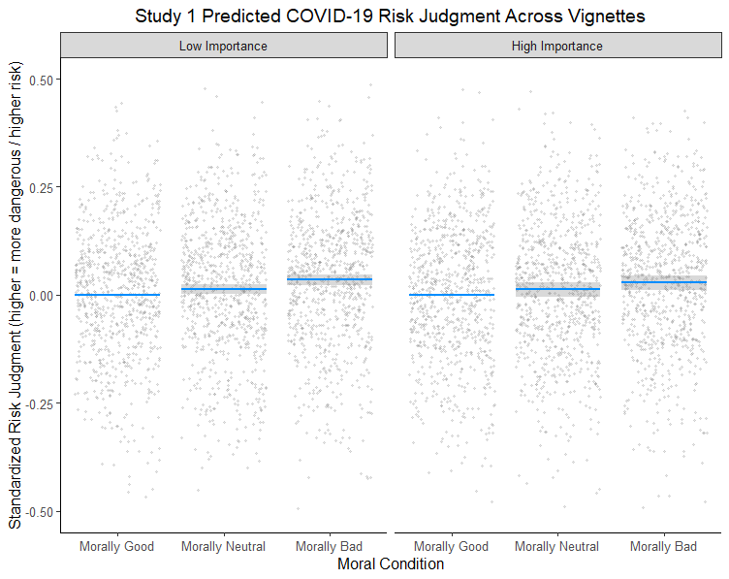
Note: Shaded gray area represents 95% confidence intervals; For visual purposes, the reference group is the morally good condition, which differs from the analysis where the reference group is the morally neutral condition; The y-axis was rescaled, excluding 24 data points from the visual range of the figure; Continuous variables were standardized and between-subjects continuous predictors were mean centered prior to analysis. The model included by-participant random intercepts, by-participant importance condition random slopes, by-vignette random intercepts, by-vignette importance condition random slopes, and correlations among random effects, and controlled for age, gender, race/ethnicity, and self-reported political orientation; Results were estimated using a restricted maximum likelihood approach; N = 841.
The first analysis tested the effect of the experimentally manipulated moral and importance conditions on perceived COVID-19 risk. As a secondary test of the hypotheses, we tested the effect of participants’ self-reported moral and importance judgments about the actions on the likelihood they thought the actions would lead to a COVID-19 infection. Importantly, the maximal random effects structure for this analysis successfully converged without issue, providing a more conservative test of the hypotheses and improving generalizability of the results compared to the prior model with moral and importance conditions. Supporting the first hypothesis, there was a significant effect of moral judgment on COVID-19 risk. The more participants judged the actions as immoral, the more they thought the actions could lead to a COVID-19 infection, β = .04, SE = .01, t(4.95) = 3.84, p = .012, marginal R² = .0710, conditional R² = .6990 (Figure 2A; Tables S51 and S52; see Figures S4 and S5 for effect sizes across vignettes). However, there was no effect of importance judgment, β = -.01, SE = .01, t(4.37) = -1.27, p = .269 (Figure 2B), and no moral x importance judgment interaction (β < .001, SE = .01, t(4.88) = .09, p = .930) on COVID-19 risk judgments.

Figure 2
(A) (B)
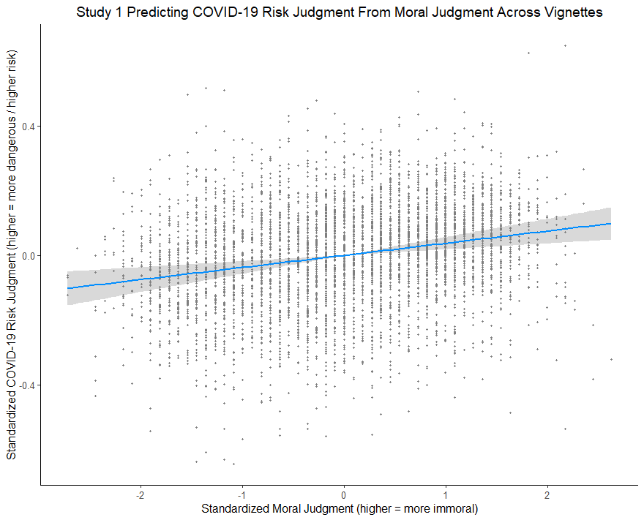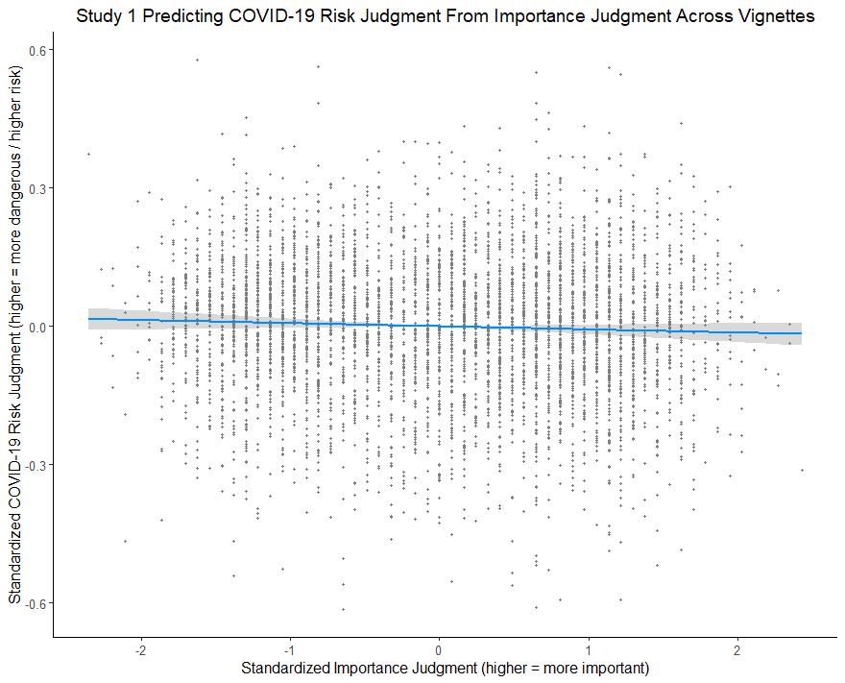
Note: Shaded area represents 95% confidence intervals; Continuous variables were standardized, between-subjects continuous predictors were mean centered, and continuous within-subjects predictors were cluster-mean centered, prior to analysis. Random effects in the model included by-participant random intercepts, by-participant moral judgment random slopes, by-participant importance judgment random slopes, by-vignette random intercepts, by-vignette moral judgment random slopes, by-vignette importance judgment random slopes, by-vignette moral x importance judgment interaction random slopes, and correlations among these random effects. Fixed effects in the model included the moral x importance judgment interaction term, age, gender, race, and self-reported political orientation; Results were estimated using a restricted maximum likelihood approach; N = 841.
Together, results demonstrate that how participants felt morally about the actions affected their perceptions of how likely it is the actions will lead to COVID-19 infection. Counter to the second hypothesis, there was no effect of how important an action is on how risky the action is perceived to be in a COVID-19 context. In addition to morality, there were also significant associations between demographic covariates and COVID-19 risk perceptions. Participants who were older (β = .02, SE = .01, t(832.39) = 3.23, p = .001) and identify as women (compared to men; β = .05, SE = .02, t(837.41) = 3.04, p = .002) saw greater COVID-19 risk across the scenarios. Moreover, the more participants identified as conservative, the less likely they thought the actions would lead to COVID-19 infection (β = -.06, SE = .01, t(830.17) = -9.45, p < .001).

5. Experiment 2: Intentionality and COVID-19 Risk
In study 2 we investigated the effect of the intention manipulation on COVID-19 risk judgments, as well as the effect of subjects’ individual intention judgment on COVID-19 risk.
5.1. Design. Participants read and responded to four vignettes as described in section 2. For
each vignette, participants were first asked the risk question described in study 1. Participants then answered the intentionality question administered in the pretest.
5.2. Participants. All subjects completed both experiment 1 and experiment 2, meaning that participants were the same for both experiments.
5.3. Data Analysis. The same mixed effects modeling procedures as study 1 were followed for study 2. There are two random variables in study 2: participant with 841 levels and vignette with four levels. By-vignette random slopes were not specified in study 2 models because there are only four vignettes. As a manipulation check, a mixed-effects model was constructed predicting overall intention judgment from intention condition, controlling for covariates, with by-participant random intercepts, by-participant intention condition random slopes, by-vignette random intercepts, and correlation between random intercepts and slopes (see Supplemental Material).
To test the main hypothesis for study 2, a mixed-effected model was constructed predicting COVID-19 risk judgment from intention condition, controlling for covariates, with by-participant random intercepts, by-participant intention condition random slopes, by-vignette random intercepts, and correlation between random intercepts and slopes. As a secondary test of the hypothesis, a mixed-effected model was constructed predicting COVID-19 risk judgment from intention judgment, controlling for covariates, with by-participant random intercepts, by-participant intention condition random slopes, by-vignette random intercepts, and correlation between random intercepts and slopes.
5.3. Results and Discussion. Full results are presented in the Supplemental Material Tables S53-S58 and Figures S6-S8. The manipulation check confirmed the intention condition manipulation worked. Participants judged the actions as more intentional in the intentional conditions than the same actions in the unintentional conditions, β = .35, SE = .01, t(838.00) = 48.18, p < .001, marginal R² = .3880, conditional R² = .5490 (Figures S8 and S9; Tables S53 and S54). Supporting the hypothesis for study 2, there was a significant effect of intention condition on COVID-19 risk judgments. Participants judged the actions as more likely to lead to a COVID-19 infection when the actions were committed intentionally than when they were committed unintentionally, β = .02, SE = .01, t(836.20) = 4.20, p < .001, marginal R² = .0255, conditional R² = .5330 (Figure 3; Figure S10; Tables S55 and S56)

Figure 3
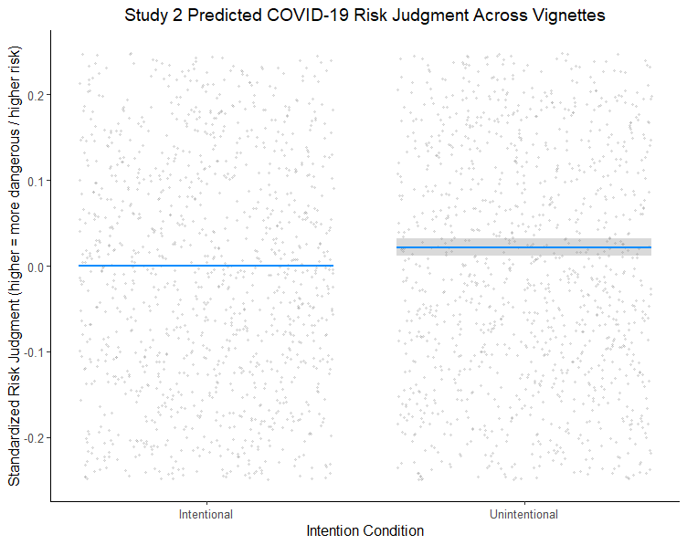
Note: Shaded area represents 95% confidence intervals; Reference group = unintentional; The y-axis was rescaled, excluding 1,052 data points from the visual range of the figure; Continuous variables were standardized, between-subjects continuous predictors were mean centered, and continuous within-subjects predictors were cluster-mean centered, prior to analysis. The model included by-participant random intercepts, by-participant intention condition random slopes, by-vignette random intercepts, and correlation between random intercepts and random slopes, and controlled for age, gender, race, and self-reported political orientation; Results were estimated using a restricted maximum likelihood approach; N = 841.

Like study 1, a secondary analysis was conducted testing the effect of intention judgment on COVID-19 risk judgment. This was the same model as the prior analysis, except that participants’ self-reported judgments of how intentional they perceived the actions to be was the main predictor that replaced intention condition. Results supported the hypothesis: the more participants judged the actions as intentional, the more likely they thought the actions could lead to a COVID-19 infection, β = .04, SE = .01, t(765.72) = 7.30, p < .001, marginal R² = .0330, conditional R² = .5570 (Figure 4; Tables S57 and S58). Moreover, participants who identified as older, β = .03, SE = .01, t(829.26) = 2.18, p = .030, and more politically liberal, β = -.03, SE = .01, t(829.11) = -3.05, p = .002, perceived significantly greater risk of COVID-19 infection across the vignettes than younger participants and participants who identified as more conservative, respectively.

Figure 4
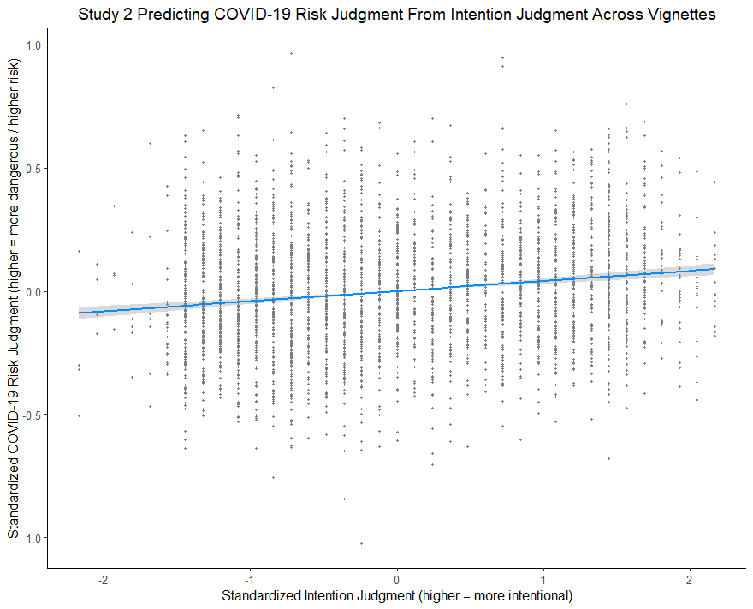
Note: Shaded area represents 95% confidence intervals; Continuous variables were standardized, between-subjects continuous predictors were mean centered, and continuous within-subjects predictors were cluster-mean centered, prior to analysis. The model included by-participant random intercepts, by-participant intention judgment random slopes, by-vignette random intercepts, and correlation between random intercepts and random slopes, and controlled for age, gender, race, and self-reported political orientation; Results were estimated using a restricted maximum likelihood approach; N = 841.
6. General Discussion
The studies presented here investigated how moral judgments, importance judgments, and judgments of intentionality affect judgments of risk related to COVID-19. Our first study showed that even when details of possible exposure were held fixed, the less moral an individual’s reasons for exposure, the more risky their actions were seen to be. Our second study showed the same for intentionality – when people intentionally put themselves in a situation in which they might get COVID, participants judged the situation to be riskier. Given prior work showing the tight link between intentionality and moral culpability, this provides two strains of evidence that moral evaluations impact judgments of COVID-19 risk.
It is worth noting that while the effect size here is small, this does not necessarily mean it is an unimportant effect. First, the effect of morality on risk was demonstrated using hypothetical scenarios in which participants were not personally involved. It is possible that the effect could be stronger in real-world situations with implications for participants. It is also possible that such small effects can have a big impact when repeated over time (Prentice & Miller, 1992). That is, if these moral judgments influence many small decisions about exposure across a population, they might significantly influence emergent group behavior. Small effects of this sort might also be relevant if media and scientific sources regularly miscommunicate about risks related to COVID-19 as a result, thus further impacting risk judgments of the wider community. In addition, the effects we identify are congruous with previous findings investigating the impacts of moral judgments on risk judgments (Thomas et al., 2016; Relihan et al., in prep). Both of these studies used designs very similar to the one employed here, and found convergent results. The robustness of the phenomena across topic matter and study suggests that it is, indeed, a notable effect, even if the effect size is small in this instance.
In a related study by Timmons et al. (2021) subjects judged the risk of COVID infection in the face of alternative medical, financial, and psychosocial risks. As in our study, the authors present vignettes where exposure is fixed, but the reasons for exposure vary. They find that when the vignettes include more serious medical and psychosocial “risks”- for instance, if an individual really must see a doctor or has been terribly lonely - participants judge the exposure risks lower. The authors suggest that this is an instance of the affect heuristic, where affective response to a proposed activity influences risk judgments. That is, if the anticipated excitement and pleasure of an activity is greater than the fear of harm, this will color judgments so that the activity is perceived as less risky (Slovic et al., 2007.; Finucane et al., 2000). On their picture, there is competition between two sources of negative affect – COVID risk and other risk – and the greater fear of medical or psychosocial risk drives down judgments of COVID risk.
In some ways, the manipulations in their vignettes are similar to our importance condition in that individuals have better or worse reasons for exposure, but those reasons for exposure are not necessarily moral ones in the sense we attempt to elicit in this study. This said, it is not entirely clear whether their results are in fact driven by the moral effect we observe. During a pandemic, any action that could potentially increase one’s own exposure risk, and thereby increase the risk of exposing others, could be judged immoral. Moreover, in our first study we found a moderate (negative, due to the scales we used) correlation (Pearson r = -.62, 95% CI[-.64, -.61], p < .001) between importance judgments and judgments of moral valence across vignettes. This indicates that highly moral actions are considered important, and highly important actions are more morally justifiable. Without controlling for separate influences of these judgments, it is hard to know just what factor is driving judgments related to COVID risk in the Timmons study. Our design, which permitted us to test the effects of both importance and moral judgments on risk judgments while controlling for the other, suggests that it is moral judgments that matter. That said, it is possible that the reason we did not find a significant effect of importance on risk judgments was because the effect is small, and we did not generate enough vignettes to have adequate power to see the effect. Further research is needed to determine whether importance judgments alone impact risk judgments.
Notably, Relihan et al. (in prep) also appeal to the affect heuristic as a possible explanation for the influence of moral judgment on risk judgment. As they point out, previous work shows that moral judgments are often driven by “gut feelings” (Haidt, 2001; Haidt & Joseph, 2004), and associated with affective responses (Graham et al., 2013), which may prompt judgments that morally laudable actions are less risky, and morally culpable actions are more so. It may be that this heuristic is responsible, or partly responsible, for the results we observe here.
Another relevant phenomenon to our results might be “just world beliefs”. Many studies have found that people believe the world is just, i.e., that good things happen to good people and bad things to bad people, despite ample evidence to the contrary (Lerner, 1980; Lerner & Miller, 1978; Furnham & Procter, 1989; Furnham, 2003). Beliefs of this sort may help individuals deal with a chaotic world by projecting control, stability, and orderliness onto it (Lerner & Miller, 1978). Typical investigations look into unfair attributions of dessert or culpability after individuals have already suffered some misfortune. For instance, those with strong beliefs in a just world might be especially likely to attribute immoral behavior to an AIDs patient (Furnham, 2003). Our results may in part arise from just world beliefs applied before some misfortune occurs. Those who expose themselves to COVID without good reason for doing so are morally culpable, and in a just world they would be the ones infected with the illness. Thus their risk is judged higher. This relates to moral coherence as discussed by Clark et al. (2015).
One challenge for our experimental design was to properly control for perceived exposure. We used identical wording across vignettes to describe the potential COVID exposure. Other details in the vignettes, though, might influence beliefs about this exposure event. For instance, we describe Joe as living in a “small city apartment”. Joe’s exposure involves being caught in an elevator with five neighbors for 25 minutes. In some vignettes Joe is a cocaine user, while in another he has a job that requires him to rush out to FedEx. Readers might assume that a cocaine user lives in a different sort of neighborhood than someone with pressing job responsibilities. This, in turn, might influence inferences about the sorts of neighbors Joe would have, their chances of contracting COVID-19, and thus Joe’s chances of contracting it from them. On this picture, one might think that observed shifts in risk judgment are based in rational inference. Note, though, that it is very hard to disambiguate this interpretation of our results from one where moral judgments are influencing reasoning. If moral judgments influence reasoning about objective risk, those influenced will presumably develop justificatory factual beliefs supporting their risk judgments to avoid cognitive dissonance. Determining whether or not such factual beliefs are post hoc, i.e., following from a moral judgment, or follow directly from reasoning about the scenario is difficult.
At the beginning of the paper, we suggested that certain COVID infographics may reflect inaccurate risk assessments along the lines of those we document in this paper. Again, though, there are several explanations for why these infographics may track factors other than risk. It may be that the experts generating them were influenced by moral judgments in the same way that subjects in our study were. In assessing behaviors like going to the beach, they may have judged these riskier because they seemed morally irresponsible during a pandemic. On the other hand, these experts might have been making calculated decisions about what behaviors members of the public should engage in all things considered. Knowing that the infographics would directly shape behavior, they may have used them as a way to offer good advice on behavior, rather than to offer information about risk. One vein of argument, though, suggests that deceptive or misleading public health messaging may decrease public trust in science (Dayrit et al., 2020; OECD, 2020). Thus, it may be worthwhile for public health experts to consider whether such infographics should be altered to fall more in line with objective COVID-19 risks. There may be other policy implications for future public health messaging. In particular, our results suggest that individuals may be prone to underestimate the risks of behaviors that they consider highly morally laudatory, such as attending church or participating in a protest. If so, it may be worthwhile to create direct messaging about such behaviors, emphasizing their true riskiness.
The COVID-19 pandemic has created enormously difficult decisions for individuals trying to balance the risks of the pandemic against the demands of everyday life. Good decision making in such scenarios can have life and death consequences. For this reason, it is important to understand what drives risk assessments during a pandemic, and, in particular, to investigate the ways that these assessments might deviate from ideal risk assessments. As we show here, moral judgments may play a role in shaping risk judgments, and thus in shaping choices during a pandemic. These results are not relevant only to the current pandemic, however. They add to a growing literature suggesting that moral evaluations shape risk judgment more generally. When it comes to other important medical judgments with moral character, such as those surrounding pregnancy for instance, we might expect similar effects. If so, patients and doctors may be systematically failing to make appropriate choices on the basis of objective risks.
Acknowledgements
This material is based upon work supported by the National Science Foundation under Grant No.1922424. Many thanks to Barbara Sarnecka for initial discussions about this study. Thanks to the members of Peter H. Ditto’s lab group at UC Irvine for feedback on a draft of this paper. Thanks also to Roxane Cohen Silver and members of her lab group for feedback on a final draft.

References
Alicke, M. D. (1992). Culpable causation. Journal of Personality and Social Psychology, 63(3), 368-378. https://doi.org/10.1037/0022-3514.63.3.368
Alicke, M. D. (2000). Culpable control and the psychology of blame. Psychological Bulletin, 126(4), 556-574. https://doi.org/10.1037/0033-2909.126.4.556
Ames, D. L., & Fiske, S. T. (2013). Intentional harms are worse, even when they’re not. Psychological Science, 24(9), 1755-1762. https://doi.org/10.1177/0956797613480507
Barr, D. J., Levy, R., Scheepers, C., & Tily, H. J. (2013). Random effects structure for confirmatory hypothesis testing: Keep it maximal. Journal of Memory and Language, 68(3), 255-278. https://doi.org/10.1016/j.jml.2012.11.001
Brauer, M., & Curtin, J. J. (2018). Linear mixed-effects models and the analysis of nonindependent data: A unified framework to analyze categorical and continuous independent variables that vary within-subjects and/or within-items. Psychological Methods, 23(3), 389-411. https://doi.org/10.1037/met0000159
Burra, A., & Knobe, J. (2006). The folk concepts of intention and intentional action: A cross-cultural study. Journal of Cognition and Culture, 6(1-2), 113-132. https://doi.org/10.1163/156853706776931222
Clark, C. J., Chen, E. E., & Ditto, P. H. (2015). Moral coherence processes: Constructing culpability and consequences. Current Opinion in Psychology, 6, 123-128. https://doi.org/10.1016/j.copsyc.2015.07.016
Combs, B., & Slovic, P. (1979). Newspaper coverage of causes of death. Journalism Quarterly, 56(4), 837-849. https://doi.org/10.1177/107769907905600420
Cushman, F. (2008). Crime and punishment: Distinguishing the roles of causal and intentional analyses in moral judgment. Cognition, 108(2), 353-380. https://doi.org/10.1016/j.cognition.2008.03.006
Cushman, F., Knobe, J., & Sinnott-Armstrong, W. (2008). Moral appraisals affect doing/allowing judgments. Cognition, 108(1), 281-289. https://doi.org/10.1016/j.cognition.2008.02.005
Dayrit, M. M., Mendoza, R. U., & Valenzuela, S. A. (2020). The importance of effective risk communication and transparency: Lessons from the dengue vaccine controversy in the Philippines. Journal of Public Health Policy, 41(3), 252-267. https://doi.org/10.1057/s41271-020-00232-3
R Core Team (2020). R: A language and environment for statistical computing. Vienna, Austria. https://www.R-project.org
Feinberg, M., & Willer, R. (2019). Moral reframing: A technique for effective and persuasive communication across political divides. Social and Personality Psychology Compass, 13(12), e12501. https://doi.org/10.1111/spc3.12501
Finucane, M. L., Alhakami, A., Slovic, P., & Johnson, S. M. (2000). The affect heuristic in judgments of risks and benefits. Journal of Behavioral Decision Making, 13(1), 1-17. https://doi.org/10.1002/(sici)1099-0771(200001/03)13:1<1::aid-bdm333>3.0.co;2-s
French, P. E. (2011). Enhancing the legitimacy of local government pandemic influenza planning through transparency and public engagement. Public Administration Review, 71(2), 253-264. https://doi.org/10.1111/j.1540-6210.2011.02336.x
Furnham, A. (2003). Belief in a just world: Research progress over the past decade. Personality and Individual Differences, 34(5), 795-817. https://doi.org/10.1016/s0191-8869(02)00072-7
Furnham, A., & Procter, E. (1989). Belief in a just world: Review and critique of the individual difference literature. British Journal of Social Psychology, 28(4), 365-384. https://doi.org/10.1111/j.2044-8309.1989.tb00880.x
Graham, J., Haidt, J., Koleva, S., Motyl, M., Iyer, R., Wojcik, S. P., & Ditto, P. H. (2013). Moral foundations theory: The pragmatic validity of moral pluralism. In Advances in experimental social psychology (Vol. 47, pp. 55-130). Academic Press. https://doi.org/10.1016/b978-0-12-407236-7.00002-4
Haidt, J. (2001). The emotional dog and its rational tail: a social intuitionist approach to moral judgment. Psychological Review, 108(4), 814-834. https://doi.org/10.1037/0033-295X.108.4.814
Haidt, J., & Joseph, C. (2004). Intuitive ethics: How innately prepared intuitions generate culturally variable virtues. Daedalus, 133(4), 55-66. https://doi.org/10.1162/0011526042365555
Hitchcock, C., & Knobe, J. (2009). Cause and norm. The Journal of Philosophy, 106(11), 587-612. https://doi.org/10.5840/jphil20091061128
Kenward, M. G., & Roger, J. H. (1997). Small sample inference for fixed effects from restricted maximum likelihood. Biometrics, 53(3), 983-997. https://doi.org/10.2307/2533558
Knobe, J. (2003). Intentional action and side effects in ordinary language. Analysis, 63(3), 190-194. https://doi.org/10.1093/analys/63.3.190
Knobe, J. (2014). Person as scientist, person as moralist. In Experimental philosophy (pp. 195-228). Oxford: Oxford University Press. https://doi.org/10.1093/acprof:osobl/9780199927418.003.0009
Kominsky, J. F., Phillips, J., Gerstenberg, T., Lagnado, D., & Knobe, J. (2015). Causal superseding. Cognition, 137, 196-209. https://doi.org/10.1016/j.cognition.2015.01.013
Lerner, M. J. (1980). The belief in a just world. In The Belief in a just world (pp. 9-30). Springer, Boston, MA.
Lerner, M. J., & Miller, D. T. (1978). Just world research and the attribution process: Looking back and ahead. Psychological Bulletin, 85(5), 1030-1051. https://doi.org/10.1037/0033-2909.85.5.1030
Liu, B. S., & Ditto, P. H. (2013). What dilemma? Moral evaluation shapes factual belief. Social Psychological and Personality Science, 4(3), 316-323. https://doi.org/10.2139/ssrn.2071478
Nakagawa, S., & Schielzeth, H. (2013). A general and simple method for obtaining R2 from generalized linear mixed‐effects models. Methods in Ecology and Evolution, 4(2), 133-142. https://doi.org/10.1111/j.2041-210x.2012.00261.x
Nichols, S., & Knobe, J. (2007). Moral responsibility and determinism: The cognitive science of folk intuitions. Nous, 41(4), 663-685. https://doi.org/10.1111/j.1468-0068.2007.00666.x
OECD. (2020) Transparent, communication, and trust: The role of public communication in responding to the wave of disinformation about the new coronavirus. Technical report.
Prentice, D. A., & Miller, D. T. (1992). When small effects are impressive. Psychological Bulletin, 112(1), 160-164. https://doi.org/10.1037/0033-2909.112.1.160 .
Raudenbush, S. W., & Bryk, A. S. (2002). Hierarchical linear models (2nd ed.). Thousand Oaks,
CA: Sage
Read, S. J., Vanman, E. J., & Miller, L. C. (1997). Connectionism, parallel constraint satisfaction processes, and gestalt principles:(Re) introducing cognitive dynamics to social psychology. Personality and Social Psychology Review, 1(1), 26-53. https://doi.org/10.1207/s15327957pspr0101_3
Relihan, D. P., Thomas, A.K., and Ditto, P.H. (in press). Wrong is risky: Moral intuitions bias risk perception.
Shaver, K. G. (2012). The attribution of blame: Causality, responsibility, and blameworthiness. Springer Science & Business Media.
Singmann, H., & Kellen, D. (2019). An introduction to mixed models for experimental psychology. New Methods in Cognitive Psychology, 28, 4-31. https://doi.org/10.4324/9780429318405-2
Slater, M. D., & Rasinski, K. A. (2005). Media exposure and attention as mediating variables influencing social risk judgments. Journal of Communication, 55(4), 810-827. https://doi.org/10.1111/j.1460-2466.2005.tb03024.x
Slovic, P., Finucane, M. L., Peters, E., & MacGregor, D. G. (2007). The affect heuristic. European Journal of Operational Research, 177(3), 1333-1352. https://doi.org/10.1016/j.ejor.2005.04.006
Stegmueller, D. (2013). How many countries for multilevel modeling? A comparison of frequentist and Bayesian approaches. American Journal of Political Science, 57(3), 748-761. https://doi.org/10.1111/ajps.12001
Thagard, P. (2000). Coherence in thought and action. MIT press. https://doi.org/10.7551/mitpress/1900.001.0001
Thomas, A. J., Stanford, P. K., and Sarnecka, B. W. (2016). No child left alone: Moral judgments about parents affect estimates of risk to children. Collabra, 2(1):1–14. https://doi.org/10.1525/collabra.33
Timmons, S., Belton, C. A., Robertson, D. A., Barjaková, M., Lavin, C., Julienne, H., & Lunn, P. (2020). Is it Riskier to Meet 100 People Outdoors Or 14 People Indoors?: Comparing Public and Expert Perceptions of COVID-19 Risk. ESRI. https://doi.org/10.31234/osf.io/qeb9s

Appendix A. Vignettes
Study 1, Condition 1: Morally Good, High Importance
Joe | Mina | Alex | Barbara | George | Justine
During the COVID-19 pandemic, Joe (52) was living alone in a small city apartment. Because he could work remotely, he was mostly staying home. One day Joe got a call from his friend Alice, an older woman who lived down the block. A circuit breaker had tripped, and her AC was no longer working. It was getting dangerously hot in her apartment. She wanted Joe to reset the breaker, which was in the basement of her building and hard for her to access. Joe decided to rush over.  Joe went to the elevator and got on. On the next floor down five people entered the elevator laughing and talking. None of them were wearing masks. Before reaching the ground, a malfunction caused the elevator to get stuck. It took 25 minutes for maintenance to repair the elevator, and for Joe to exit. | Mina (41) runs a restaurant in a small tourist town. During the COVID-19 pandemic, Mina was forced to shut down for several months. Mina’s earnings normally help support her elderly mother. During this time she was forced to spend all her savings and take on debt to pay their bills and buy food. In addition, Mina’s mother started showing symptoms of osteoporosis, but refused to go to the doctor because she was worried about Mina’s financial state. Mina grew increasingly desperate to get her mother to the doctor.  Mina decided to reopen. For two weeks Mina worked 12 hours a day running the restaurant with her staff of four before being forced to shut down again. While at work Mina and her staff wore masks at all times. Customers, mostly tourists, wore masks while moving about the restaurant, but not while sitting and eating. | During the COVID-19 pandemic, Alex (21) missed seeing friends, but was doing all right living in a rented house in the small town where he grew up. One evening, a close friend, Greg, called to say that he was really struggling and was considering hurting himself. He was drunk and sitting at the local bar. Alex decided to rush over and try to calm Greg down.  Alex was at the bar for about an hour. It was fairly crowded, with about 20 people in one small room. They ranged in age from mid-twenties to around sixty. Most of them had their masks off and were drinking beer and talking loudly. | During the COVID-19 pandemic, Barbara (60) was living alone in her townhome in a small city. She had retired earlier that year, and was spending her time talking on zoom with friends and her children. One day, her daughter called in a panic because Barbara’s grandson had a strange rash and fever. Her daughter was too busy taking care of him to investigate and asked Barbara to please google the symptoms. Barbara’s internet was down, but she knew that she could use the computers at the local library. She decided to head over there.  Barbara was at the library for about an hour. Altogether, 25 people came through the library while she was there. About half of them were wearing masks. Barbara wore her mask for 30 minutes, but then took it off because it was uncomfortable. | During the COVID-19 pandemic, George (35) was living with his wife and three children in a small suburban home. One day his wife realized that she had not ordered a refill of their five-year old son’s asthma medication, which she usually got delivered. She asked George to please drive to the store, since their son needed to take his medicine every night to prevent asthma attacks. George decided to go right away.  George was at the store for about 45 minutes. It was packed with people who had just gotten off from work and were buying groceries for dinner. They were wearing masks, but were not entirely able to social distance given the crowding. | During the COVID-19 pandemic, Justine (26) was living in an apartment in the city. She was mostly social distancing, though missed normal social life. Her sister, Jane, had been fighting late-stage breast cancer for the past several years. One day Jane called to tell Justine that she was going to stop treatments given how advanced the cancer was. The doctors expected that she would only have another month or so in decent health. Jane had a special request that Justine take her for one last evening at their favorite club. Justine agreed to do so.  Justine was at the club for four hours. It was a large room, with about 100 young people laughing and dancing. She danced and drank, and flirted with a few men. No one was wearing masks.

Study 1, Condition 2: Morally Good, Low Importance
Joe | Mina | Alex | Barbara | George | Justine
During the COVID-19 pandemic, Joe (52) was living alone in a small city apartment. Because he could work remotely, he was mostly staying home. One day Joe got a call from his friend Alice, an older woman who lived down the block. A circuit breaker had tripped, and her TV was no longer working. She wanted Joe to reset the breaker, which was in the basement of her building and hard for her to access. Joe decided to head over and help her.  Joe went to the elevator and got on. On the next floor down five people entered the elevator laughing and talking. None of them were wearing masks. Before reaching the ground, a malfunction caused the elevator to get stuck. It took 25 minutes for maintenance to repair the elevator, and for Joe to exit. | Mina (41) runs a restaurant in a small tourist town. During the COVID-19 pandemic, Mina was forced to shut down for several months. During this time, she was supported by government aid, and had just enough money to pay her bills and buy food. For her five year old niece, Amy’s, upcoming birthday, Mina really wanted to get her a nice new bike. Amy had been asking for months, but her parents could afford not it. It became increasingly clear that Mina couldn’t get the money for the bike together without going back to work.  Mina decided to reopen. For two weeks Mina worked 12 hours a day running the restaurant with her staff of four before being forced to shut down again. While at work Mina and her staff wore masks at all times. Customers, mostly tourists, wore masks while moving about the restaurant, but not while sitting and eating. | During the COVID-19 pandemic, Alex (21) missed seeing friends, but was doing all right living in a rented house in the small town where he grew up. One evening, a close friend, Greg, called to say that he was feeling lonely and sad. He was drunk and sitting at the local bar. Alex decided to head over and cheer up his friend.  Alex was at the bar for about an hour. It was fairly crowded, with about 20 people in one small room. They ranged in age from mid-twenties to around sixty. Most of them had their masks off and were drinking beer and talking loudly. | During the COVID-19 pandemic, Barbara (60) was living alone in her townhome in a small city. She had retired earlier that year, and was spending her time talking on zoom with friends and her children. One day, her daughter called because she was confused about her taxes and was hoping her mother could look up some information. Barbara’s internet was down, but she knew that she could use the computers at the local library. She decided to head over there.  Barbara was at the library for about an hour. Altogether, 25 people came through the library while she was there. About half of them were wearing masks. Barbara wore her mask for 30 minutes, but then took it off because it was uncomfortable.  . | During the COVID-19 pandemic, George (35) was living with his wife and three children in a small suburban home. One day his wife realized that she had not ordered balloons for their five year old son’s birthday. Since their son had been unable to see friends for several months, they wanted to make sure his birthday was special. George decided to drive to the store and get balloons right away, since they would be celebrating the birthday that night.  George was at the store for about 45 minutes. It was packed with people who had just gotten off from work and were buying groceries for dinner. They were wearing masks, but were not entirely able to social distance given the crowding. | During the COVID-19 pandemic, Justine (26) was living in an apartment in the city. She was mostly social distancing, though missed normal social life. Her sister, Jane, was living alone in the same city. Jane had been having a rough time, and was especially lonely since the pandemic started. One day Jane called with a special request that Justine take her for an evening at their favorite club. Justine agreed to do so.  Justine was at the club for four hours. It was a large room, with about 100 young people laughing and dancing. She danced and drank, and flirted with a few men. No one was wearing masks.

Study 1, Condition 3: Morally Neutral, High Importance
Joe | Mina | Alex | Barbara | George | Justine
During the COVID-19 pandemic, Joe (52) was living alone in a small city apartment. Because he could work remotely, he was mostly staying home. One day Joe realized he did not mail a crucial work document that should have gone out several days before. Given the urgency, he decided to take it to FedEx for same day delivery.  Joe went to the elevator and got on. On the next floor down five people entered the elevator laughing and talking. None of them were wearing masks. Before reaching the ground, a malfunction caused the elevator to get stuck. It took 25 minutes for maintenance to repair the elevator, and for Joe to exit. | Mina (41) runs a restaurant in a small tourist town. During the COVID-19 pandemic, Mina was forced to shut down for several months. During this time, she was forced to spend all her savings and take on debt to pay her bills and buy food. Mina grew increasingly desperate over her financial state.  Mina decided to reopen. For two weeks Mina worked 12 hours a day running the restaurant with her staff of four before being forced to shut down again. While at work Mina and her staff wore masks at all times. Customers, mostly tourists, wore masks while moving about the restaurant, but not while sitting and eating. | During the COVID-19 pandemic, Alex (21) missed seeing friends, but was doing all right living in a rented house in the small town where he grew up. The construction company where he worked, however, went out of business. With no work, Alex found himself in increasingly dire financial straits. His landlord started threatening to evict Alex. One evening, Alex’s close friend, Greg, called to say that he could lend Alex some money to pay the rent. Greg was having a beer at the local bar and wanted Alex to meet him there. Alex decided to head over and pick up the money.  Alex was at the bar for about an hour. It was fairly crowded, with about 20 people in one small room. They ranged in age from mid-twenties to around sixty. Most of them had their masks off and were drinking beer and talking loudly. | During the COVID-19 pandemic, Barbara (60) was living alone in her townhome in a small city. She had retired earlier that year, and was spending her time talking on zoom with friends and her children. One day, Barbara got a credit card bill in her name, although she had not opened that account. Alarmed, she wanted to quickly protect herself from further identity theft. Barbara’s internet was down, but she knew that she could use the computers at the local library. She decided to head over there.  Barbara was at the library for about an hour. Altogether, 25 people came through the library while she was there. About half of them were wearing masks. Barbara wore her mask for 30 minutes, but then took it off because it was uncomfortable. | During the COVID-19 pandemic, George (35) was living with his wife and three children in a small suburban home. One day George realized he had not ordered a refill of his asthma medication, which he usually got delivered. George decided to go to the store and get it right away since he needed to take his medicine every night to prevent asthma attacks  George was at the store for about 45 minutes. It was packed with people who had just gotten off from work and were buying groceries for dinner. They were wearing masks, but were not entirely able to social distance given the crowding. | During the COVID-19 pandemic, Justine (26) was living in an apartment in the city. She was mostly social distancing, though missed normal social life. Justine was also struggling financially. Before the pandemic, she used to work weekends as a club promoter to make ends meet. Without that extra pay, she was behind on rent, and had recently gotten an eviction notice. She got a call from the club saying they were reopening, and asking her to come back. Justine decided to do so that evening.  Justine was at the club for four hours. It was a large room, with about 100 young people laughing and dancing. She danced and drank, and flirted with a few men. No one was wearing masks.

Study 1, Condition 4: Morally Neutral, Low Importance
Joe | Mina | Alex | Barbara | George | Justine
During the COVID-19 pandemic, Joe (52) was living alone in a small city apartment. Because he could work remotely, he was mostly staying home. One day Joe decided he’d like a comic book to read that evening.  Joe went to the elevator and got on. On the next floor down five people entered the elevator laughing and talking. None of them were wearing masks. Before reaching the ground, a malfunction caused the elevator to get stuck. It took 25 minutes for maintenance to repair the elevator, and for Joe to exit. | Mina (41) runs a restaurant in a small tourist town. During the COVID-19 pandemic, Mina was forced to shut down for several months. During this time, she was supported by government aid, but had just enough money to pay her bills and buy food. For her birthday, Mina really wanted to get a nice new exercise bicycle. It became increasingly clear that she couldn’t get the money together without going back to work.  Mina decided to reopen. For two weeks Mina worked 12 hours a day running the restaurant with her staff of four before being forced to shut down again. While at work Mina and her staff wore masks at all times. Customers, mostly tourists, wore masks while moving about the restaurant, but not while sitting and eating. | During the COVID-19 pandemic, Alex (21) was lucky enough to keep his job working outside in landscaping. He missed seeing friends, but was doing all right living in a rented house in the small town where he grew up. One evening, Alex’s friend Greg called to suggest that they meet at the local bar. Alex decided to head over and see Greg.  Alex was at the bar for about an hour. It was fairly crowded, with about 20 people in one small room. They ranged in age from mid-twenties to around sixty. Most of them had their masks off and were drinking beer and talking loudly. | During the COVID-19 pandemic, Barbara (60) was living alone in her townhome in a small city. She had retired earlier that year, and was spending her time talking on zoom with friends and her children. One day, Barbara wanted to download a few knitting patterns to keep herself busy. Barbara’s internet was down, but she knew that she could use the computers at the local library. She decided to head over there.  Barbara was at the library for about an hour. Altogether, 25 people came through the library while she was there. About half of them were wearing masks. Barbara wore her mask for 30 minutes, but then took it off because it was uncomfortable. | During the COVID-19 pandemic, George (35) was living with his wife and three children in a small suburban home. One day George realized he had not ordered more of his favorite kind of coffee, which he usually got delivered. George decided to go to the store and get it that day, since he wanted to have it for the next morning.  George was at the store for about 45 minutes. It was packed with people who had just gotten off from work and were buying groceries for dinner. They were wearing masks, but were not entirely able to social distance given the crowding. | During the COVID-19 pandemic, Justine (26) was living in an apartment in the city. She was mostly social distancing, though missed normal social life. One evening she saw that her favorite club was reopening. Justine decided to go that evening.  Justine was at the club for four hours. It was a large room, with about 100 young people laughing and dancing. She danced and drank, and flirted with a few men. No one was wearing masks.

Study 1, Condition 5: Morally Bad, High Importance
Joe | Mina | Alex | Barbara | George | Justine
During the COVID-19 pandemic, Joe (52) was living alone in a small city apartment. Because he could work remotely, he was mostly staying home. Joe owed his drug dealer, Pat, about $200 from a recent cocaine purchase. Pat called to tell Joe that if he didn’t drop the money in Pat’s mail chute that day, there would be serious consequences. Joe decided to head over immediately.  Joe went to the elevator and got on. On the next floor down five people entered the elevator laughing and talking. None of them were wearing masks. Before reaching the ground, a malfunction caused the elevator to get stuck. It took 25 minutes for maintenance to repair the elevator, and for Joe to exit. | Mina (41) runs a restaurant in a small tourist town. During the COVID-19 pandemic, Mina was forced to shut down for several months. During this time, she was unable to afford to support her gambling habit. She continued to gamble online, falling further and further into debt. Mina grew increasingly desperate over her financial state.  Mina decided to reopen. For two weeks Mina worked 12 hours a day running the restaurant with her staff of four before being forced to shut down again. While at work Mina and her staff wore masks at all times. Customers, mostly tourists, wore masks while moving about the restaurant, but not while sitting and eating. | During the COVID-19 pandemic, Alex (21) missed seeing friends, but was doing all right living in a rented house in the small town where he grew up. The construction company where he worked, however, went out of business. With no work, Alex found himself in increasingly dire financial straits. His landlord started threatening to evict Alex. One evening, his close friend Greg called to ask Alex to meet him at the local bar. Alex knew that Greg would likely get drunk, and once he did it would be easy to steal a few hundred dollars from Greg’s wallet. Alex decided to head over and see Greg.  Alex was at the bar for about an hour. It was fairly crowded, with about 20 people in one small room. They ranged in age from mid-twenties to around sixty. Most of them had their masks off and were drinking beer and talking loudly. | During the COVID-19 pandemic, Barbara (60) was living alone in her townhome in a small city. She had retired earlier that year, and was spending her time talking on zoom with friends and her children. Since retiring Barbara had also been making some extra cash helping a doctor friend, Ava, deliver illegal pain medications to neighbors. One day Ava called in a panic, worried that the police were going to arrest them. Barbara wanted to quickly do some legal research to protect herself, but didn’t want a search record on her computer. She knew that she could use the computers at the local library. She decided to head over there.  Barbara was at the library for about an hour. Altogether, 25 people came through the library while she was there. About half of them were wearing masks. Barbara wore her mask for 30 minutes, but then took it off because it was uncomfortable. | During the COVID-19 pandemic, George (35) was living with his wife and three children in a small suburban home. George’s wife, Linda, suffers from a serious pain condition, and takes prescription pain medication each morning to manage it. George had recently started sneaking her pills in the evening to relax and enjoy himself. One day, he realized that her pills had run out. Knowing she had to have the pills the next morning, and not wanting Linda to figure out what he had done, George decided to go to the store that day and refill them at the pharmacy.  George was at the store for about 45 minutes. It was packed with people who had just gotten off from work and were buying groceries for dinner. They were wearing masks, but were not entirely able to social distance given the crowding. | During the COVID-19 pandemic, During the COVID-19 pandemic, Justine (26) was living in an apartment in the city. She was mostly social distancing, though missed normal social life. Justine was also struggling financially. Before the pandemic, she used to scam unsuspecting men for cash every weekend at the club after they had been drinking. Without that extra money, she was behind on rent, and had recently gotten an eviction notice. One evening she saw that her favorite club was reopening. Justine decided to go that evening.  Justine was at the club for four hours. It was a large room, with about 100 young people laughing and dancing. She danced and drank, and flirted with a few men. No one was wearing masks.

Study 1, Condition 6: Morally Bad, Low Importance
Joe | Mina | Alex | Barbara | George | Justine
During the COVID-19 pandemic, Joe (52) was living alone in a small city apartment. Because he could work remotely, he was mostly staying home. One day Joe wanted to buy some cocaine from his dealer, Pat.  Joe went to the elevator and got on. On the next floor down five people entered the elevator laughing and talking. None of them were wearing masks. Before reaching the ground, a malfunction caused the elevator to get stuck. It took 25 minutes for maintenance to repair the elevator, and for Joe to exit. | Mina (41) runs a restaurant in a small tourist town. During the COVID-19 pandemic, Mina was forced to shut down for several months. During this time, she was supported by government aid, but had just enough money to pay her bills and buy food. The change in her financial state meant that Mina could not spend as much time gambling online as she wanted. It became increasingly clear that she couldn’t get the money together to gamble online the way she usually liked to do.  Mina decided to reopen. For two weeks Mina worked 12 hours a day running the restaurant with her staff of four before being forced to shut down again. While at work Mina and her staff wore masks at all times. Customers, mostly tourists, wore masks while moving about the restaurant, but not while sitting and eating. | During the COVID-19 pandemic, Alex (21) missed seeing friends, but was doing all right living in a rented house in the small town where he grew up. One evening, his close friend Greg called to ask Alex to meet him at the local bar. Alex knew that Greg would likely get drunk, and once he did it would be easy to steal a few hundred dollars from Greg’s wallet. Alex decided to head over and see Greg.  Alex was at the bar for about an hour. It was fairly crowded, with about 20 people in one small room. They ranged in age from mid-twenties to around sixty. Most of them had their masks off and were drinking beer and talking loudly. | During the COVID-19 pandemic, Barbara (60) was living alone in her townhome in a small city. She had retired earlier that year, and was spending her time talking on zoom with friends and her children. Since retiring Barbara had also been making some extra cash helping a doctor friend, Ava, deliver illegal pain medications to neighbors. One day Ava called to ask Barbara to email other friends who might be looking for prescriptions. Barbara’s internet was down, but she knew that she could use the computers at the local library. She decided to head over there.  Barbara was at the library for about an hour. Altogether, 25 people came through the library while she was there. About half of them were wearing masks. Barbara wore her mask for 30 minutes, but then took it off because it was uncomfortable. | During the COVID-19 pandemic, George (35) was living with his wife and three children in a small suburban home. George’s wife, Linda, suffers from a mild pain condition, and occasionally takes prescription pain medication in the morning to improve it. George had recently started sneaking her pills in the evening to relax and enjoy himself. One day, he realized that her pills had run out. Not wanting Linda to figure out what he had done, George decided to go to the store that day and refill them at the pharmacy.  George was at the store for about 45 minutes. It was packed with people who had just gotten off from work and were buying groceries for dinner. They were wearing masks, but were not entirely able to social distance given the crowding. | During the COVID-19 pandemic, Justine (26) was living in an apartment in the city. She was mostly social distancing, though missed normal social life. Before the pandemic, Justine used to scam unsuspecting men for cash every weekend at the club after they had been drinking. She usually used the money to buy nice clothes, and treat herself. With the clubs closed, she missed having the extra cash. One evening she saw that her favorite club was reopening. Justine decided to go that evening.  Justine was at the club for four hours. It was a large room, with about 100 young people laughing and dancing. She danced and drank, and flirted with a few men. No one was wearing masks.

Study 2, Condition 1: Unintentional
Olivia | Peter | Kristi | Andy
During the COVID-19 pandemic, Olivia (24) was living with her roommate Joanna. They had all been mostly careful about social distancing. One weekend, Joanna decided to invite over a group of mutual friends without telling Olivia about the plan. Olivia came home to find their friends in their living room.  Olivia passed through the small sitting room in about two minutes. Twelve friends were there drinking wine and talking. None of them were wearing masks. Olivia shut herself in her bedroom for the rest of the party. | During the COVID-19 pandemic, Peter (43) was living alone in a small city apartment. One day he headed out to get his groceries. Unbeknownst to him, his landlord decided to send a plumber by to check on the pipes in Peter’s bathroom. When Peter returned, he had no idea the plumber was working quietly in the bathroom while Peter put away his groceries. He didn’t realize until after the plumber finished working and went to leave.  Peter and the plumber were in his apartment together for nearly an hour. Neither was wearing a mask. | During the COVID-19 pandemic, Kristi (45) was living with her family in their small suburban home. One day she decided to order take-out for dinner. She called a local restaurant and placed her order, paying by credit card. Unbeknownst to Kristi the restaurant had opened its bar, and she would have to walk through it to carry out her food. She entered at one end, picked up her order, and was told to exit through the bar.  Kristi walked through the large, crowded bar. There were about 40 people talking loudly and laughing, few of whom were wearing masks. It took her about 1 minute to exit. | During the COVID-19 pandemic, Andy (33) was living in an apartment in a small city. Andy liked to read in a local park in the late afternoon. One day he headed there with his book, and fell asleep against the trunk of a tree. When Andy woke up, he found himself surrounded by protesters. He got up to leave.  Andy was in the middle of a group of several hundred protesters for about five minutes. They were wearing masks, and loudly shouting slogans. He was not wearing a mask.

Study 2, Condition 2: Intentional
Olivia | Peter | Kristi | Andy
During the COVID-19 pandemic, Olivia (24) was living with her roommate Joanna. They had all been mostly careful about social distancing. One weekend, Joanna told Olivia that she was going to invite over a group of mutual friends. Olivia could choose to stay in her room for the entire party, but decided to say hello.  Olivia passed through the small sitting room in about two minutes. Twelve friends were there drinking wine and talking. None of them were wearing masks. Olivia shut herself in her bedroom for the rest of the party. | During the COVID-19 pandemic, Peter (43) was living alone in a small city apartment. One day he headed out to get his groceries. His landlord texted to say he was going to send a plumber by to check on the pipes in Peter’s bathroom. When Peter returned, he put away his groceries while the plumber was working quietly in the bathroom.  Peter and the plumber were in his apartment together for nearly an hour. Neither was wearing a mask. | During the COVID-19 pandemic, Kristi (45) was living with her family in their small suburban home. One day she decided to order take-out for dinner. She called a local restaurant and placed her order, paying by credit card. Kristi had talked to the restaurant owner the previous day, and knew that it had opened its bar, and that she would have to walk out through the bar after getting her food. She entered at one end, picked up her order, and was told to exit through the bar.  Kristi walked through the large, crowded bar. There were about 40 people talking loudly and laughing, few of whom were wearing masks. It took her about 1 minute to exit. | During the COVID-19 pandemic, Andy (33) was living in an apartment in a small city. Andy liked to read in a local park in the late afternoon. One day he headed there with his book, and fell asleep against the trunk of a tree. When Andy woke up, he saw a group of protesters across the park. He decided to join them for a bit on his way home.  Andy was in the middle of a group of several hundred protesters for about five minutes. They were wearing masks, and loudly shouting slogans. He was not wearing a mask.

First authorship and corresponding authorship is shared between these two authors.
Second authorship reflects extra contributions with respect to statistical analysis. The remaining authors are listed in alphabetical order.
This infographic is available at: https://www.texmed.org/TexasMedicineDetail.aspx?id=54216
Further infographics along these lines are available from Dayton’s Children’s Hospital (https://www.childrensdayton.org/the-hub/risk-levels-kid-and-family-activities-during-covid-19), Grinnell College (https://www.grinnell.edu/campus-life/health-wellness/coronavirus/resources-tools/riskcalculator), and Nebraska Medicine to name a few (https://www.nebraskamed.com/COVID/7-stepsto-identify-risky-covid-19-situations).
Our preregistration is publicly available at OSF under DOI 10.17605/OSF.IO/6YVGF.
This analysis was not included in the preregistration, but provides a more conservative test of the hypotheses.
This difference was more notable than in our pretest results, which may be because this study had more power.
Some suggest a minimum of 10 levels (Raudenbush & Bryk, 2002; cf. Stegmueller, 2013; Brauer & Curtin, 2018).
This analysis was not included in the preregistration.
p = .345 when including by-vignette intention condition random slopes in the model, which may be due to having only four vignettes.

